Different number of nodes in the system: from 10 to 24 average score, three graphs different number of ap:

X: number of nodes

Y: average score of Sybil and normal nodes

Three graphs: different number of aps

**One AP:**

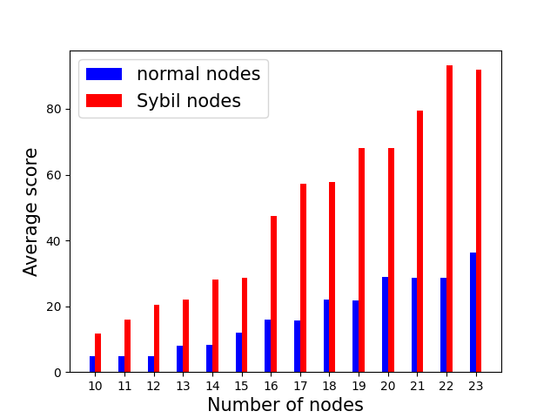

**Two AP:**

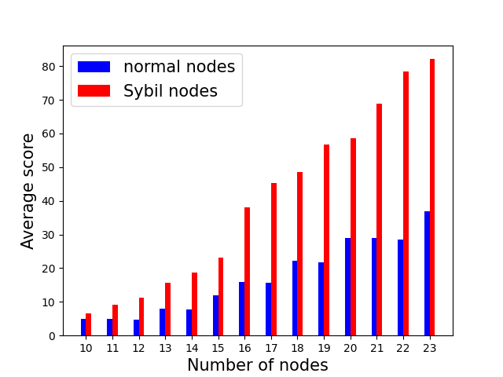

**Three AP:**

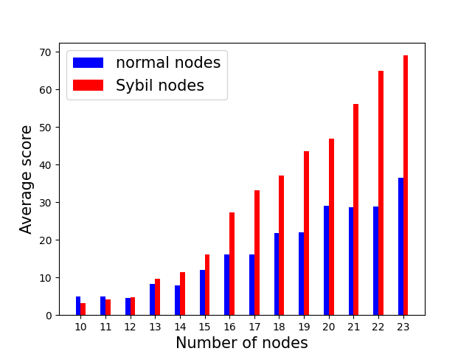

Different number of nodes in the system: from 10 to 23, Sybil elimination rate comparison, Wrong elimination rate conparison:

X: number of nodes

Y: Sybil elimination rate OR Y: normal elimination rate

Three graphs: different number of aps

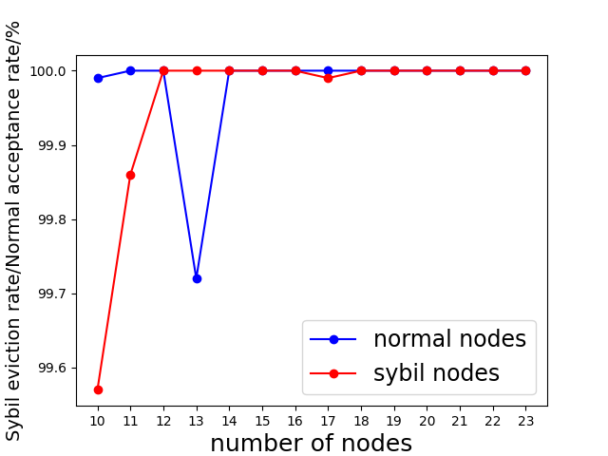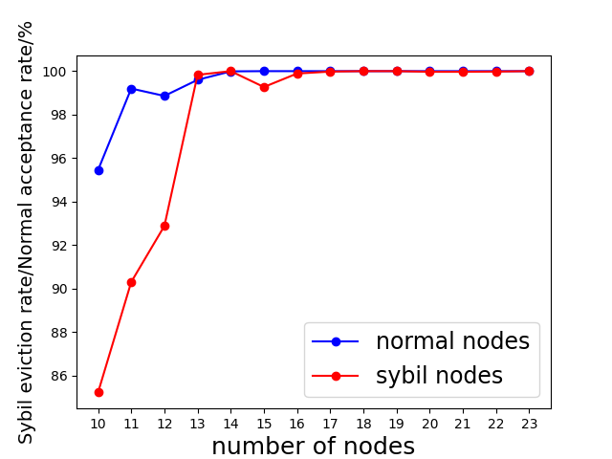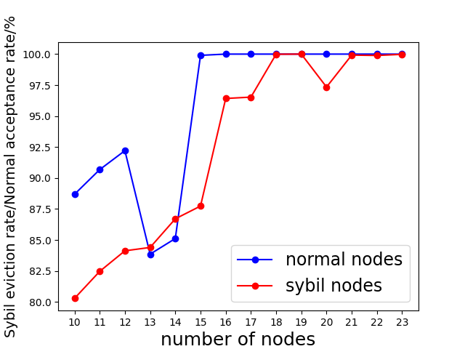

There is a drop at “13” nodes, I guess it’s because when I set 40 % of Sybil nodes in the system, it’s not exact 40%. Since we cannot have decimal number of Sybil nodes (5.2), from 12 to 13, the system add only a Sybil node. However, the number of node in the system is not enough for system to get accurate result.

16 nodes in the system, different error rate, one or two aps:

False negative stands for wrong eviction of normal nodes

False positive stands for wrong acceptance of Sybil nodes.

**One AP:**

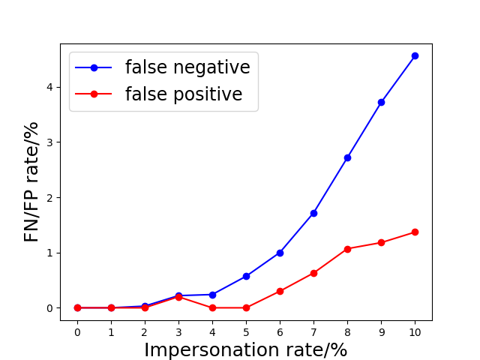

**Two AP:**

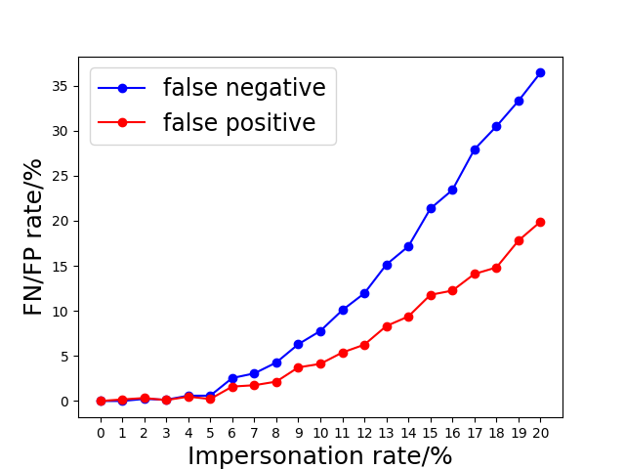

When there are 10% impersonation rate, false positive rate of a “Two AP” system is lower than 5%. The FP rate in a “One AP” system is within 2%.